# Homework Assignment (Problem Set) 2:

Note, Problem Set 2 directly focuses on Modules 3 and 4: Linear Programming and the Economic Interpretation of the Dual and Sensitivity Analysis, and Network Models.

***4 Questions***

Rubric:

All questions worth 37.5 points

37.5 Points: Answer and solution are fully correct and detailed professionally.

25-37 Points: Answer and solution are deficient in some manner but mostly correct.

15-24 Points: Answer and solution are missing a key element or two.

1-14 Points: Answer and solution are missing multiple elements are significantly deficient/incomprehensible.

0 Points: No answer provided.

Question 1:

**1A.** Write the general dual problem associated with the given LP.

*(Do not transform or rewrite the primal problem before writing the general dual)*

Maximize –4x1 + 2x2

Subject To

4x1 + x2 + x3 ≥ 20

2x1 – x2 ≤ 6

x1 – x2 + 5x3 = –5

–3x1 + 2x2 + x3 ≥ 4

x1 ≥ 0, x2 ≤ 0, x3 unrestricted

Dual of the problem is:

Minimize W = 20y1​ + 6y2​ − 5y3​ + 4y4​

Subject to:

4y1 + 2y2 + y3 – 3y4 ≤ -4

y1 – y2 – y3 + 2y4 ≥ 2

y1 + 5y3 + y4 = 0

With the variable restrictions:

y1 ≤ 0

y2 ≥ 0

y3 unrestricted

y4 ≤ 0

**1B.** Given the following information for a product-mix problem with three products and three resources.

**Primal Decision Variables:** x1 = number of unit 1 produced; x2 = # of unit 2 produced; x3 = # of unit 3 produced

**Primal Formulation: Dual Formulation:**

Max Z (Rev.) = 25x1 + 30x2 + 20x3 Min W = 50π1 + 20π2 +25π3

Subject To 8x1 + 6x2 + x3 ≤ 50 (Res. 1 constraint) Subject To 8π1 + 4π2 +2π3≥ 25

4x1 + 2x2 + 3x3 ≤ 20 (Res. 2 constraint) 6π1 + 2π2 +π3 ≥ 30  
 2x1 + x2 + 2x3 ≤ 25 (Res. 3 constraint) π1 + 3π2 +2π3≥ 20

x1, x2, x3 ≥ 0 (Nonnegativity) π1, π2, π3 ≥ 0

**Optimal Solution:**

Optimal Z = Revenue = $268.75

x1 = 0 (Number of unit 1) Dual Var. Optimal Value = 22.5 (Surplus variable in 1st dual constraint)

x2 = 8.125 (Number of unit 2) Dual Var. Optimal Value = 0 (Surplus variable in 2nd dual constraint)

x3 = 1.25 (Number of unit 3) Dual Var. Optimal Value = 0 (Surplus variable in 3rd dual constraint)

Resource Constraints:

Resource 1 = 0 leftover units Dual Var. Optimal Value = 3.125 = π1

Resource 2 = 0 leftover units Dual Var. Optimal Value = 5.625 = π2

Resource 3 = 14.375 leftover units Dual Var. Optimal Value = 0 = π3

***1Bi.*** What is the fair-market price for one unit of Resource 3?

***1Bii.*** What is the meaning of the surplus variable value of 22.5 in the 1st dual constraint with respect to the primal problem?

1Bi. **Fair-market price for one unit of Resource 3:**

The fair-market price for one unit of a resource can be inferred from the dual variable associated with that resource in the dual problem. In the given product-mix problem, the dual variable π3​ represents the shadow price or the value of one additional unit of Resource 3 to the objective function of the primal.

From the provided optimal solution:

Dual Var. Optimal Value = 0 = π3​

This means that the shadow price for one additional unit of Resource 3 is $0. Hence, the fair-market price for one unit of Resource 3 is $0.

**1Bii. Meaning of the surplus variable value of 22.5 in the 1st dual constraint:**

In the context of linear programming, the value of the surplus variable for a constraint provides insight into the amount by which the left-hand side of the constraint exceeds its right-hand side. A positive value indicates that the constraint is binding and that increasing the resource availability (or constraint right-hand side) will potentially increase the objective function value.

For the 1st dual constraint, the surplus variable value is 22.5. This means that the left-hand side of the first dual constraint exceeds its right-hand side by 22.5 units.

Considering the primal-dual relationship, the surplus in the dual corresponds to the slack in the primal. Therefore, in the primal problem, this value means that if one more unit of Resource 1 (the first resource) were available, the maximum revenue would potentially increase by 22.5 units. However, since π1​ has a positive value of 3.125, this indicates that Resource 1 is fully utilized (no slack) and is essential for maximizing the revenue. The value of 22.5 provides further insight into the sensitivity of the objective function with respect to the availability of Resource 1.

Question 2:

Seat and Greet manufactures couches and love seats. Each couch contributes $850 to profit and each love seat, $650. The resource requirements (square feet of fabric, cubic feet of stuffing, and number or workers to complete an item in one day) and availability are shown in the table below. Marketing considerations dictate that at least 50 couches and at least 40 love seats be produced.



Part A: Formulate the problem as a Linear Program.

Decision Variables: Let:

$x1​ = number of couches produced$

$x2​ = number of love seats produced$

Objective Function: The objective is to maximize profit from couches ($850 cost of one couch) and love seats (cost of one love seat is $650).

Maximize $Z=850x1+650x2$

Constraints:

Fabric constraint: $120x1+70x2≤9010$

Stuffing constraint: $40x1​+25x2​≤3500$

Workers constraint: $3x1​+2x2​≤250$

At least 50 couches: $x1​≥50$

At least 40 love seats: $x2​≥40$

Non-Negativity: $x1​,x2​≥0$

Linear Programming Problem is:

Maximize $Z=850x1​+650x2$

​

Subject to:

$$120x1​+70x2​≤9010$$

$$40x1​+25x2​≤3500$$

$$3x1​+2x2​≤250$$

$$x1​≥50$$

$$x2​≥40$$

$$x1​,x2​≥0$$

Part B: Solve the LP (provide exact values for all variables and the optimal objective function).

*Hint: The optimal objective function value is $70,450*

*[Note, I am providing this hint because having the optimal solution is necessary to do Part C.]*

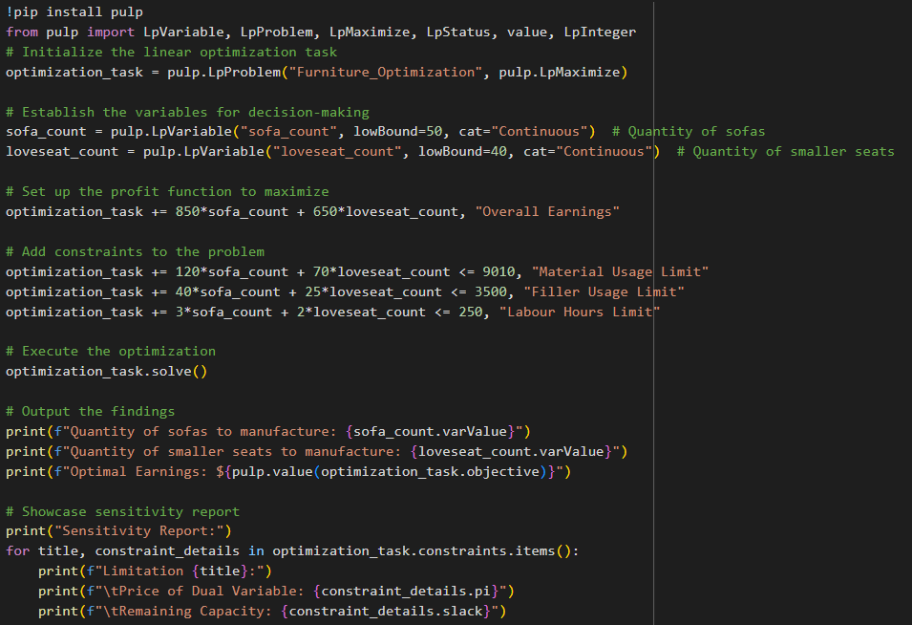

Part C: Answer the following questions from your output. *(Note, do not simply rerun the model – use the Linear Programming output and Sensitivity Analysis to explain your answers.)*

i) If couches contributed $1,000 to profit, what would be the new optimal solution to the problem (decision variables and objective function)?

To evaluate how profit changes without re-running the model:

New Maximum Profit = Original Profit + (Profit Growth per Sofa * Amount of Sofas Made)

= $70450 + ($150 * 50)

= $70450 + $7500

= $77950

Thus, the new maximum profit would be $77,950.

However, with the New Maximum Profit for sofas, the best combination of sofas and love seats to manufacture might differ. The heightened profit from each sofa may make it more appealing to manufacture a larger number of sofas compared to love seats, considering the existing limits. For a precise new best outcome regarding production quantities, the equation would have to be recalculated with the updated sofa profit figure.

ii) What is the most that Seat and Greet should be willing to pay for an extra cubic foot of stuffing?

From the provided sensitivity analysis:

Dual Value for the Stuffing_Limit: $0.00

The dual value, often referred to as the shadow price, represents the potential change in the best outcome of the objective function when there's a one-unit increment in the constraint's right-hand value, with all other parameters remaining unchanged.

For the Stuffing limit, the dual value stands at $0.00. This indicates that having an additional cubic foot of Stuffing wouldn't affect the peak profit. Essentially, given the present scenario, Stuffing isn't a bottleneck; there's an existing surplus (425.0 units) in the Stuffing constraint.

Consequently, the highest amount Seat and Greet should consider offering for an extra cubic foot of Stuffing is $0.00, as it wouldn't boost the profit based on the present configuration.

iii) If Seat and Greet were required to produce at least 45 couches, what would their profit be?

* Quantity of sofas to manufacture: 50.0 (already meeting the updated minimum of 45 sofas)
* Peak Profit: $70450.0

In the present configuration, Seat and Greet manufactures 50 sofas, surpassing the revised minimum production of 45 sofas. Hence, the present configuration aligns with this updated stipulation seamlessly.

As a result, even when considering the updated stipulation of manufacturing a minimum of 45 sofas, the profit stands unaltered at $70450.0.

iv) Seat and Greet is considering producing reclining chairs. A reclining chair contributes $500 to profit and requires 30 square feet of fabric, 15 cubic feet of stuffing, and 2 workers to produce a chair in one day). Should Seat and Greet produce any reclining chairs? **Again,** **do not rerun the model.**

Recliner Specifications:

* Earnings: $500
* Fabric: 30 square feet
* Filling: 15 cubic feet
* Labor: 2 personnel

From the Sensitivity Report:

* Dual Value for Fabric_Limit: $9.2857143
* Dual Value for Filling_Limit: $0.00
* Dual Value for Labor_Limit: $0.00

Utilizing the dual values, the prospective earnings surge, if resources for a recliner are allocated, can be computed:

Earnings Boost due to Fabric = Dual Value for Fabric × Fabric needed for recliner = $9.2857143 × 30 = $278.571429

Considering the dual values for filling and labor stand at $0.00, there's no potential increment in earnings from employing these resources.

Total potential earnings surge from resource allocation = $278.571429

Now, contrasting the potential earnings surge from resource allocation with the recliner's earnings:

* Earnings from recliner: $500
* Prospective earnings surge from resources: $278.571429

Difference = $500 - $278.571429 = $221.428571

The profit from crafting a recliner surpasses the prospective profits rise from resource allocation towards other items. Hence, in light of the present configuration and sensitivity report, Seat and Greet ought to consider recliner production, as it results in extra earnings of $221.43 per recliner crafted.

Question 3:

Suppose you are in the market to buy a new car for $20,000. The maintenance costs for this car are dependent on its age in years (see table below). However, you can avoid growing maintenance costs by trading in the car at any point, the value of which is also dependent on its age in years (see same table below). Suppose that if you trade a car in at any point in the next 5 years, the cost of the new car you purchase is still $20,000. You hope to minimize the net cost of having a car over the next five years (purchase costs + maintenance costs – trade-in value).



Part A: Formulate this as a shortest-path network problem and draw the network. As a hint, think about the cost associated with having the car from year 1 to year 2 - $20,000 + $3,000 - $12,000 = $11,000. What is it from year 1 to year 3, or year 2 to year 3?

Part B: Solve the problem and give the best plan (shortest path) to have a car for the next 5 years at the lowest cost.

Starting with an initial cost of the car at $20,000:

Year 1:

* Keep the car: $20,000 + $3,000 = $23,000
* Buy a new car: $23,000 - $12,000 + $20,000 = $31,000
* Decision: Keep the car

Year 2:

* Keep the car: $23,000 + $5,000 = $28,000
* Buy a new car: $28,000 - $10,000 + $20,000 = $38,000
* Decision: Keep the car

Year 3:

* Keep the car: $28,000 + $7,000 = $35,000
* Buy a new car: $35,000 - $6,000 + $20,000 = $49,000
* Decision: Keep the car

Year 4:

* Keep the car: $35,000 + $13,000 = $48,000
* Buy a new car: $48,000 - $2,000 + $20,000 = $66,000
* Decision: Keep the car

Year 5:

* Keep the car: $48,000 + $20,000 = $68,000
* Buy a new car: $68,000 - $1,000 + $20,000 = $87,000
* Decision: Keep the car

The best plan is to keep the car for all 5 years. The total cost over the 5 years with this strategy is $68,000.

Question 4:

An average of 900 cars enter a traffic network (shown below) each hour, trying to make it from node 1 to node 9. The maximum number of cars that can pass over each arc and the time it takes a car to drive each arc is shown below. Use a minimum cost network flow model to minimize the total time for the 900 cars to drive from node 1 to node 9 (assuming all enter at the same time and traffic jams do not exist).

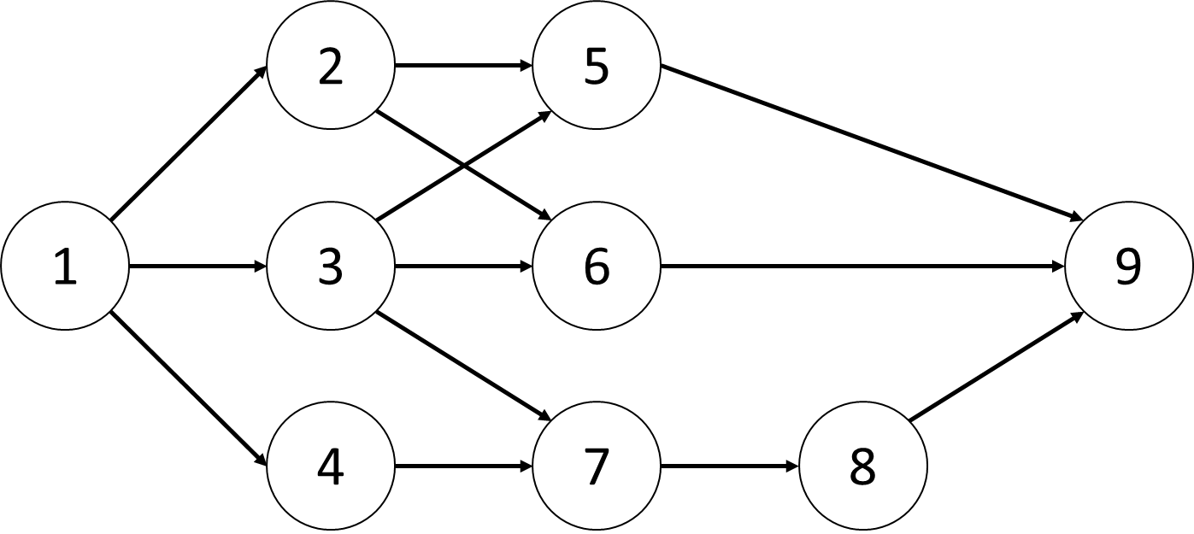 

Part A: Formulate the problem as a minimum cost network flow problem.

Given 900 cars per hour, it translates into 15 cars per minute.

Decision Variables: Let $x_{ij}$ represent the number of cars that drive from node $i$ to node $j.$

Objective Function: Minimize the total time taken by all the cars:

$$Min \sum_{∀(i,j)}{x_{ij}}*{Time}_{ij}$$

Considering, the values given in the table, Minimize:

${Total Travel Time T=16x}_{12}+30x_{13}+7x_{14}+17x_{25}+12x_{26}+x_{35}+4x_{36}+18x_{37}+20x_{47}+13x_{56}+5x_{59}+5x_{69}+2x_{78}+7x_{89}$

Constraints:

1. For node 1(source): $x_{12}+x_{13}+x_{14}=15$
2. For node 2: $x_{12}=x_{25}+x_{26}$
3. For node 3: $x_{13}=x_{35}+x_{36}+x_{37}$
4. For node 4: $x_{14}=x_{47}$
5. For node 5: $x_{25}+x_{35}=x_{56}+x_{59}$
6. For node 6: $x_{26}+x_{36}+x_{56}=x_{69}$
7. For node 7: $x_{37}+x_{47}=x_{78}$
8. For node 8: $x_{78}=x_{89}$
9. For node 9(sink): $x_{59}+x_{69}+x_{89}=15$

Capacity Constraints:

$0≤x_{12}≤500$

$0≤x_{13}≤500$

$0≤x_{14}≤400$

$0≤x_{25}≤300$

$0≤x_{26}≤350$

$0≤x_{35}≤400$

$0≤x_{36}≤300$

$0≤x_{37}≤250$

$0≤x_{47}≤400$

$0≤x_{56}≤200$

$0≤x_{59}≤600$

$0≤x_{69}≤900$

$0≤x_{78}≤700$

$0≤x_{89}≤700$

Part B: Solve the problem and provide the solution (decision variables and objective function).

Question 5:

A university has three professors who each teach four courses per year. Each year, four sections of marketing, finance, and production must be offered. At least one section of each class must be offered during each semester (fall and spring). Each professor’s time preferences and preference for teaching various courses are given below.

The total satisfaction a professor earns teaching a class is the sum of the semester satisfaction and the course satisfaction. Thus, professor 1 derives a satisfaction of 3 + 3 = 6 from teaching marketing during the fall semester.



Part A: Formulate the problem as a minimum cost network flow problem that can be used to assign professors to courses so as to maximize the total satisfaction of the three professors. Draw the network and identify the nodes and arcs.

Breaking down by each professor's preferences and each course, and explaining the costs based on hypothetical preferences.

For simplicity, assume the following notation:

P1, P2, P3 = Professors

MF, FF, PF, MS, FS, PS = Courses. The first letter represents the semester (M for Monsoon, F for Fall, and P for Spring), and the second letter represents the nature of the course (F for Freshman, S for Senior).

Professor 1 (P1):

* Teaching Marketing in Fall: 3 (semester) + 3 (course) = 6
* Teaching Finance in Fall: 3 (semester) + 7 (course) = 10
* Teaching Production in Fall: 3 (semester) + 5 (course) = 8
* Teaching Marketing in Spring: 4 (semester) + 3 (course) = 7
* Teaching Finance in Spring: 4 (semester) + 7 (course) = 11
* Teaching Production in Spring: 4 (semester) + 5 (course) = 9

Professor 2 (P2):

* Teaching Marketing in Fall: 5 (semester) + 5 (course) = 10
* Teaching Finance in Fall: 5 (semester) + 4 (course) = 9
* Teaching Production in Fall: 5 (semester) + 7 (course) = 12
* Teaching Marketing in Spring: 3 (semester) + 5 (course) = 8
* Teaching Finance in Spring: 3 (semester) + 4 (course) = 7
* Teaching Production in Spring: 3 (semester) + 7 (course) = 10

Professor 3 (P3):

Teaching Marketing in Fall: 4 (semester) + 5 (course) = 9

* Teaching Finance in Fall: 4 (semester) + 7 (course) = 11
* Teaching Production in Fall: 4 (semester) + 6 (course) = 10
* Teaching Marketing in Spring: 5 (semester) + 5 (course) = 10
* Teaching Finance in Spring: 5 (semester) + 7 (course) = 12
* Teaching Production in Spring: 5 (semester) + 6 (course) = 11

This gives us the total satisfaction score each professor derives from teaching a particular subject in a particular term. Now, these values can be used to update the network graph, placing them on the arcs connecting professors to terms and courses.

Let be a binary variable:

* 1, if Professor $i$ teaches Course $j$ in Term $k$.
* 0, otherwise.

Where:

* $i$ can be 1, 2, or 3 (Professor 1, Professor 2, Professor 3).
* $j$ can be M, F, or P (Marketing, Finance, Production).
* $k$ can be F or S (Fall, Spring).

Objective Function: Maximize the total satisfaction across all assignments:

Maximize: $\sum_{i=1}^{3}{\sum_{j=M,F,P}{\sum_{k=F,S}{({term-preference}_{ik}+{course-preference}_{ij})*x_{ijk}}}}$

​

Where ${satisfaction}_{ijk}$ is the satisfaction of Professor $i$ teaching Course $j$ in Term $k$.

Constraints:

Each professor teaches exactly 4 courses a year:

$$\sum_{j=M,F,P}{\sum_{k=F,S}{x_{ijk}}}=4$$

Four Sections of each course must be offered every year:

$\sum_{i=1}^{3}{\sum_{k=F,S}{x_{ijk}}}= 4$ for each j in M,F,P

At least one section of each course must be offered each semester:

$\sum_{i=1}^{3}{x_{ijk}}≥ 1$, for each j in M,F,P and each k in F,S

Given the data, the exact satisfaction values can be plugged into the objective function, and the constraints will ensure that each course is taught exactly once per term and each professor teaches one course per term.

Part B: Solve the problem (provide exact values for all variables and the optimal objective function).



